On week6,we had identified and described the main elements of risk management and governance frameworks used in software projects.

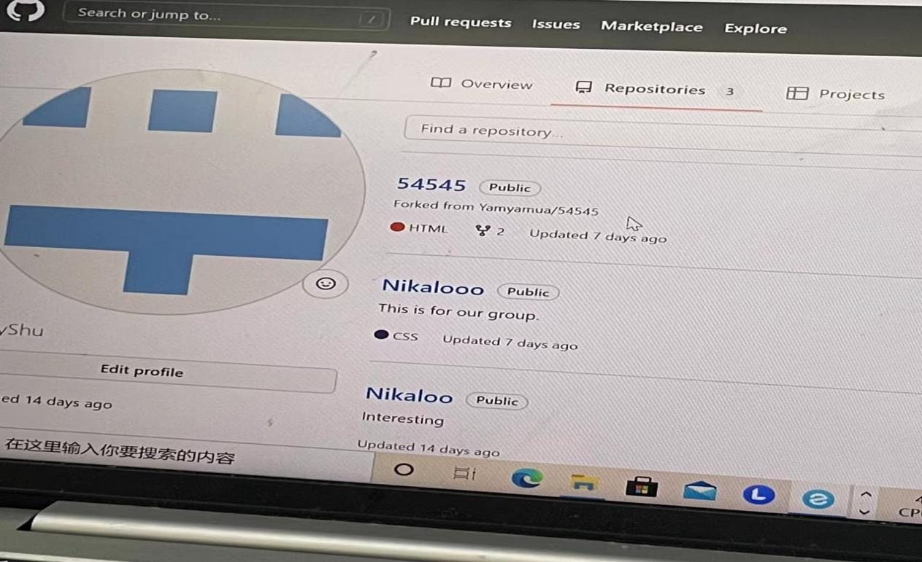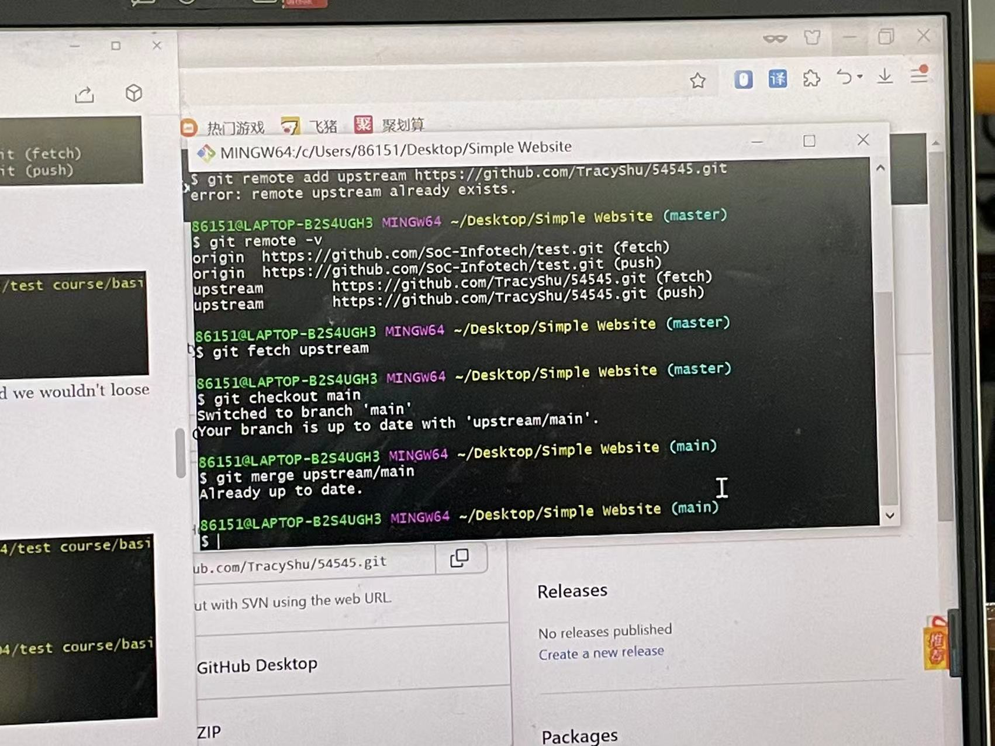First,we create a copy of that code for yourself and you can work/make changes then request those changes be merged back into that original project.

Yam Yam and Ron are responsible for visiting github and find your group repository , and create a fork. .

Tracy and Flossie are responsible for configuring git so that we are synced with that original repository that we forked from .

And then we do changes using pull request.

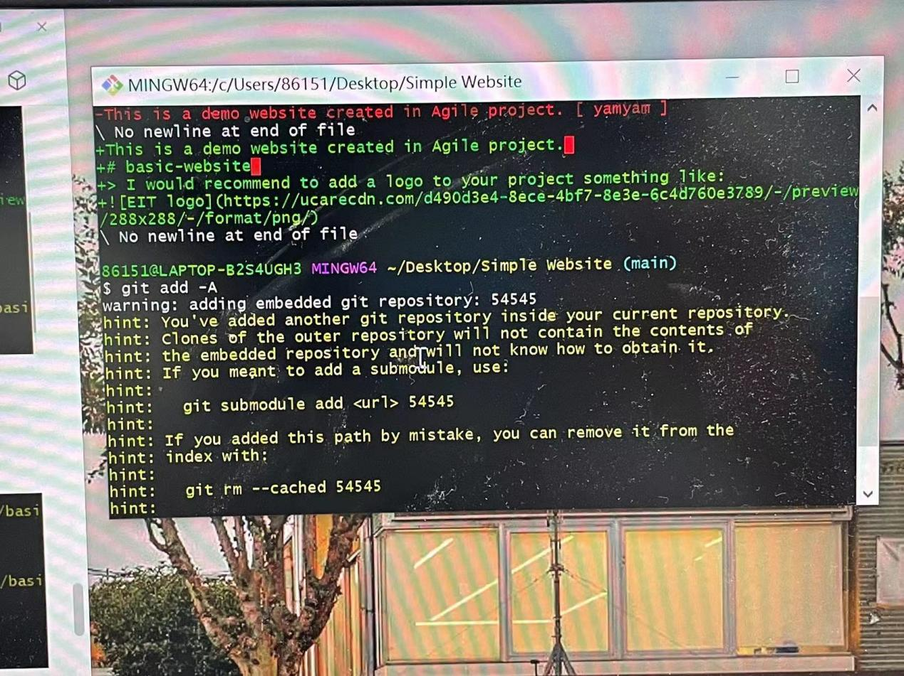

We finished Iteration 3Practical Project: Iterations 1-3 found on 'Assessments' section .

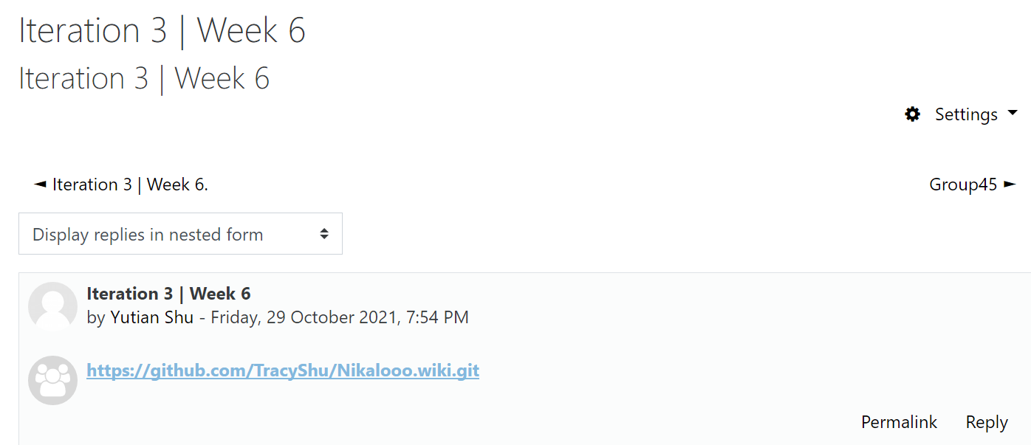

On week7,we walked through all the processes carried out during the project. We will also oversee how to improve these processes to enable more quality assurance for our products and services.

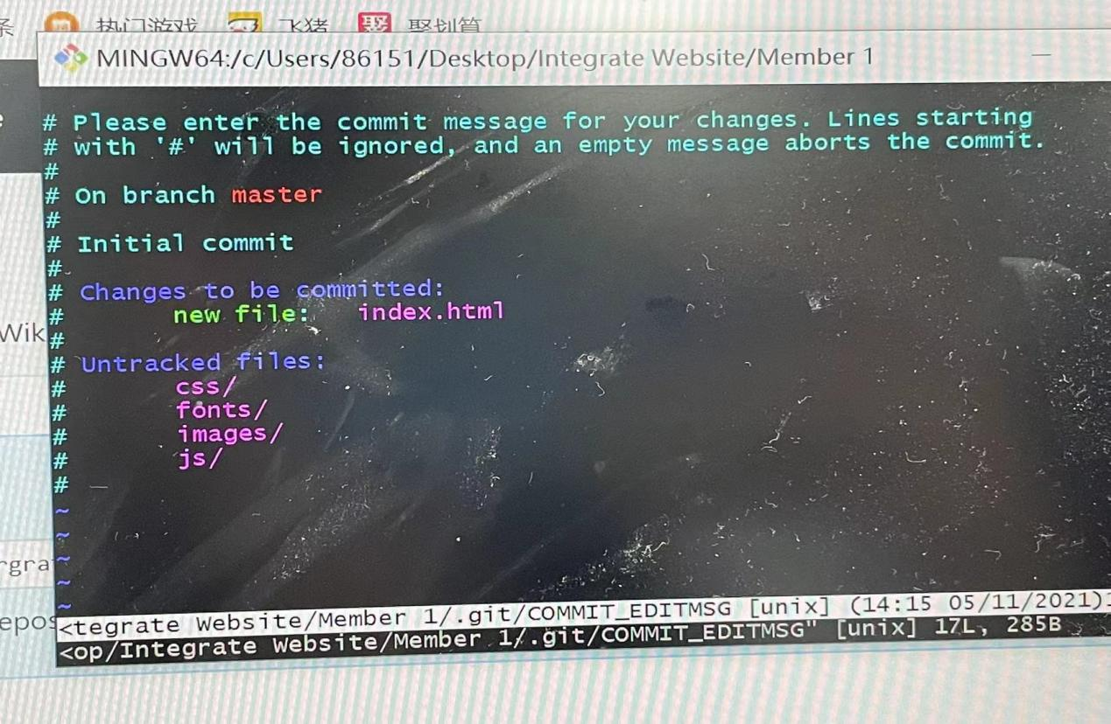First,we had finished the Lab7-GitHub pages

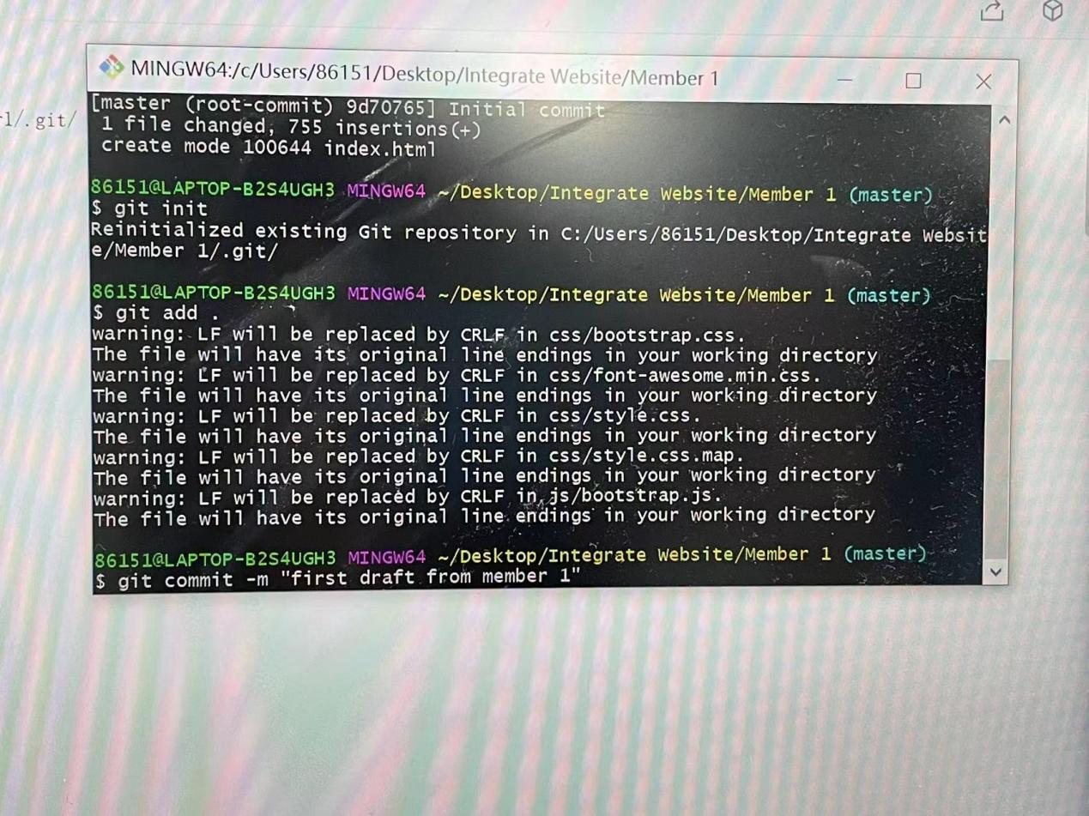

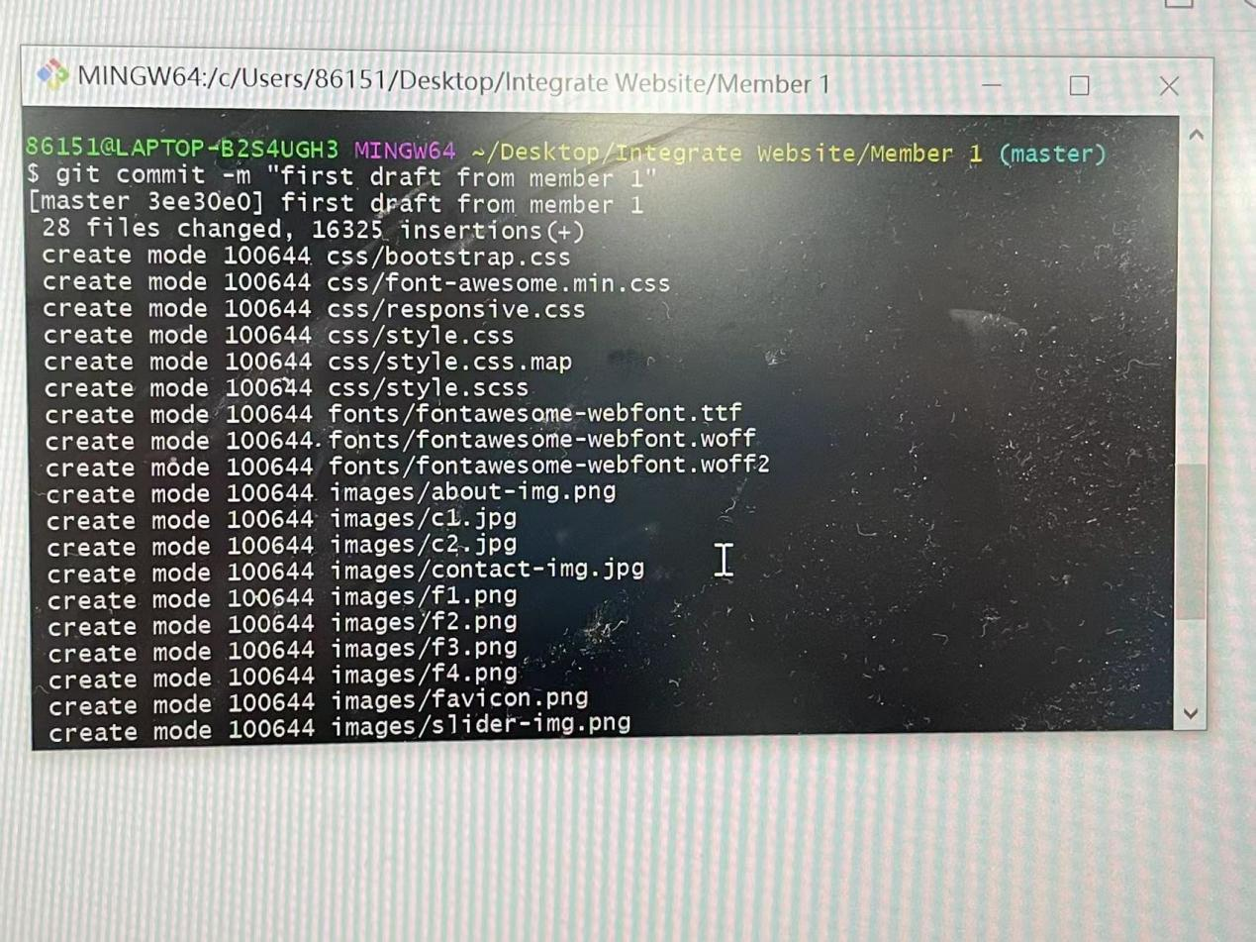

Tracy and Flossie worked on member1 and member2.

Yam Yam and Ron worked on member3 and member4.

We are working together to put these summaries together to form the answer.

And we completed the User Acceptance Testing (UAT) template File.

2.Provide feedback about what’s working, what’s not working, and what your group needs to improve on as you prepare for Iteration 3.

It is efficient to describe and apply risk management techniques to identify and mitigate risks,build and develop good quality IT projects so that would enable more quality assurance for our products and services.

But we have some problems on github and markdown because the operation is not very smooth.

And we also have some problems on Process improvement.